  
  
  
**Information Security Management  
CSE3502**

***LAB FAT  
SET 3***

Slot : L25+L26

Date : 29/04/2022

Name : Kulvir Singh

Register Number : 19BCE2074

Virus Total Report  
Using various malwares from malware bazar we get the analysis report :

**Malware 1 : 4ed1612427dd78fd270107fe98510b3d11c2a1b8a2b3b85d7890cce753ac244b**

**Report :**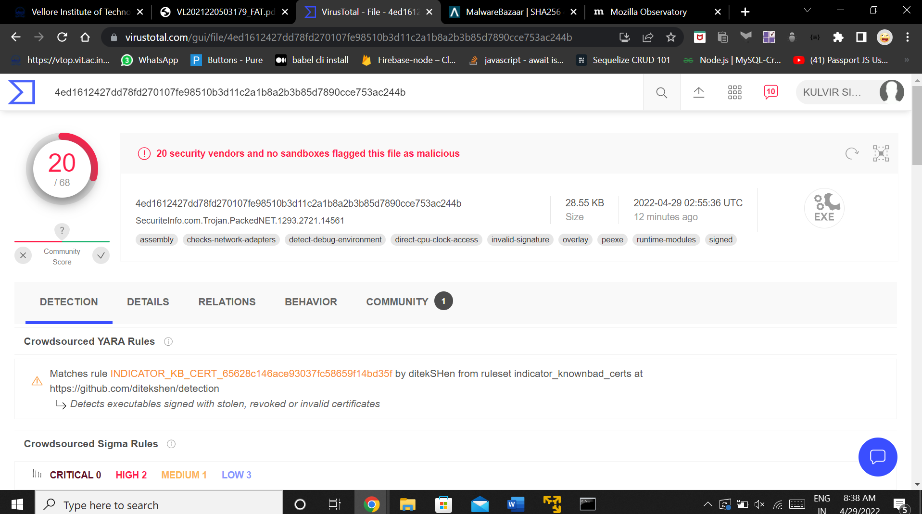

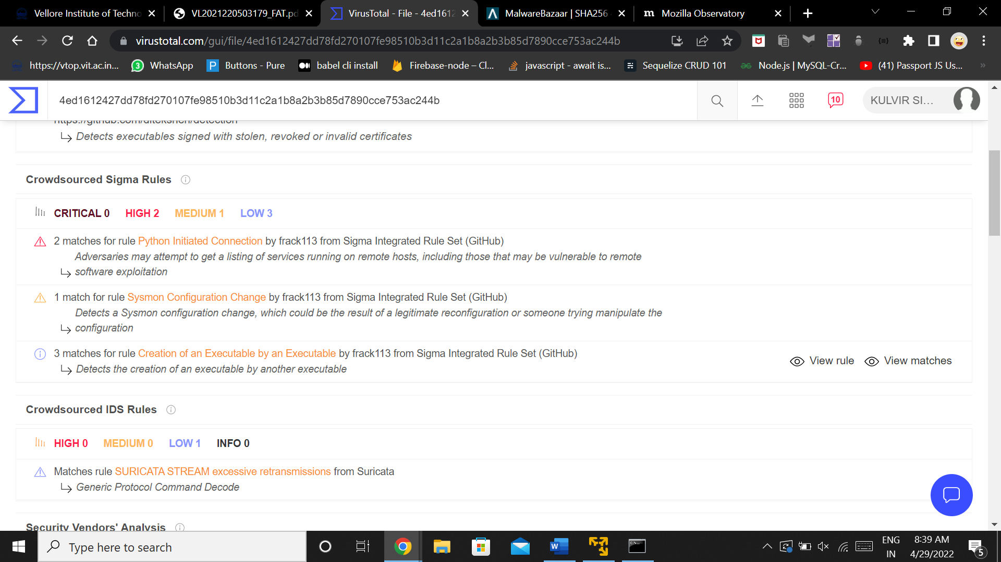

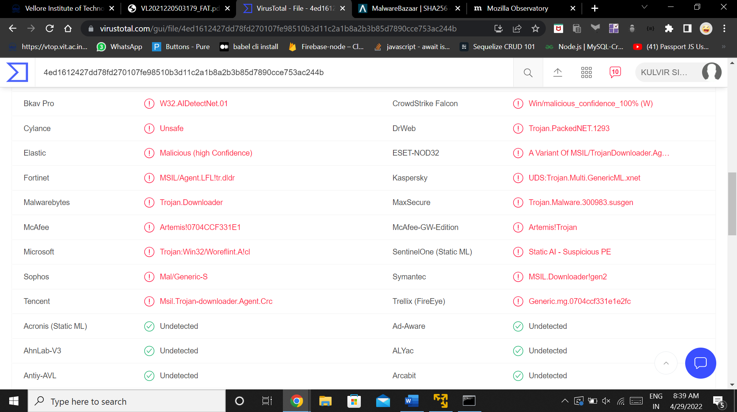

Graph

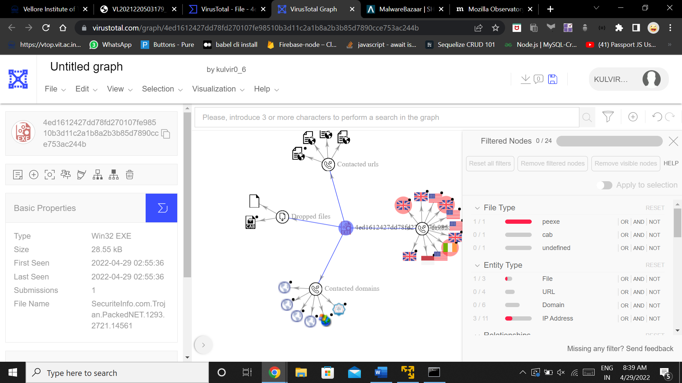

**Malware 2 : 62bc23a0472b18da02e05228ab6132d07b18300f1bfa03b9651e08e6cab87a2b**

**Report :**

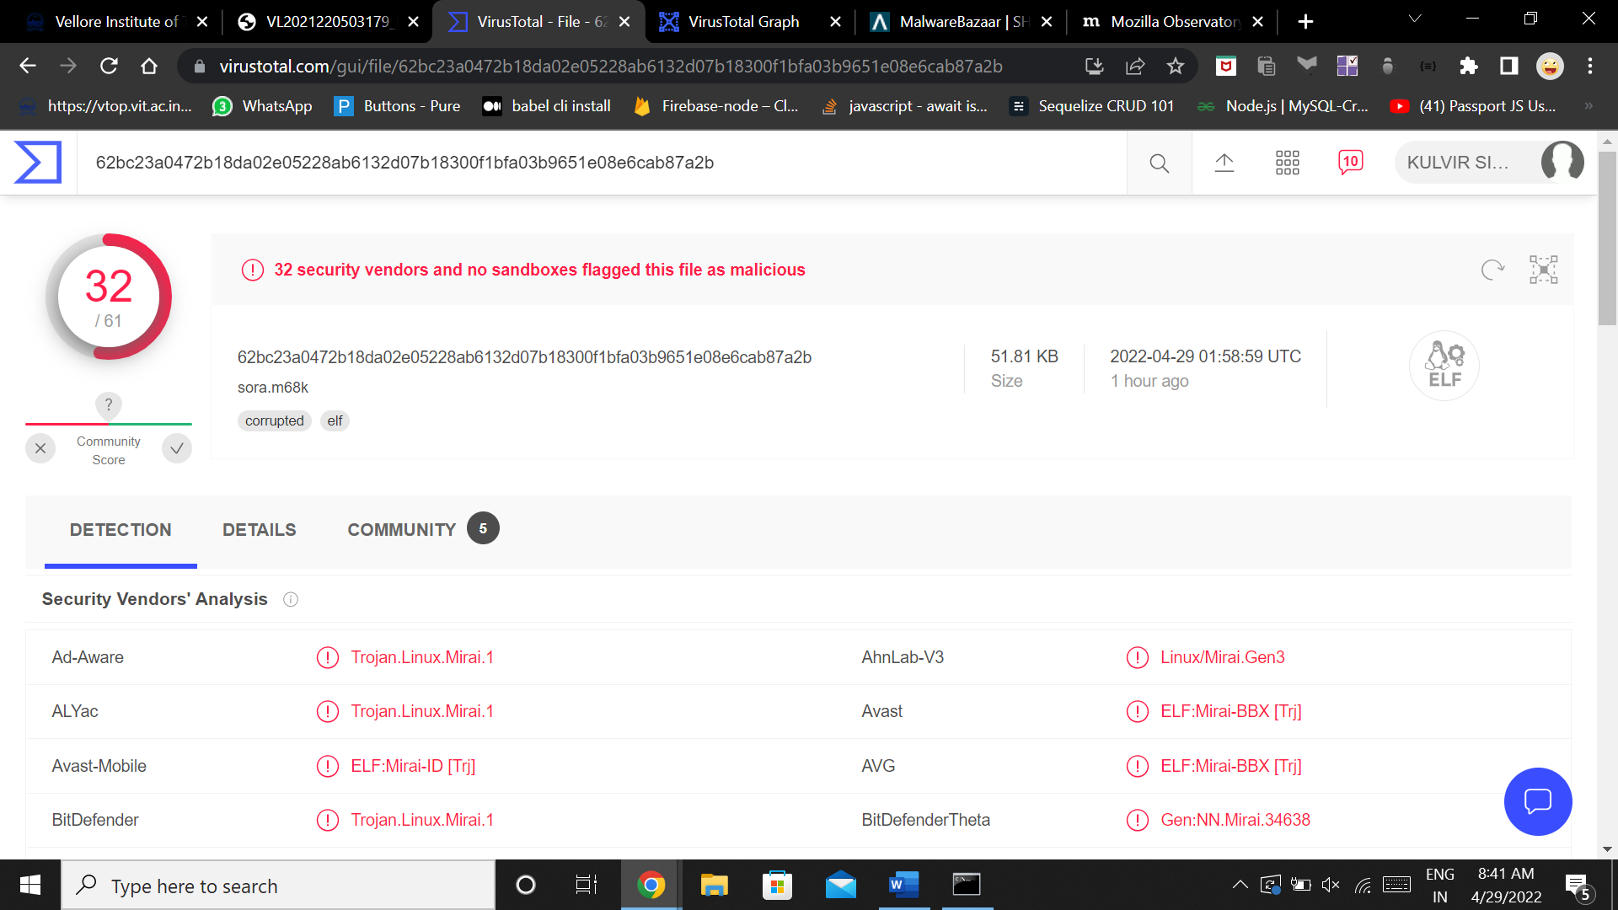

Graph :

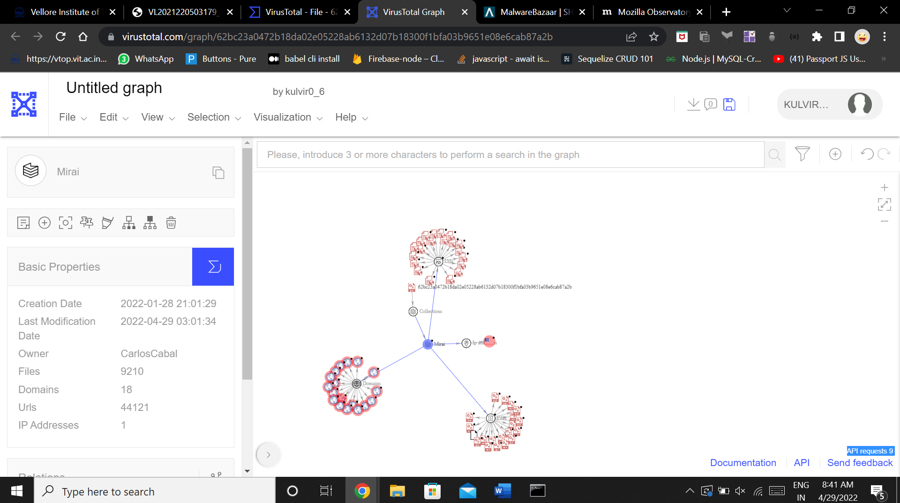

Malware 3 : 0fb85406722c1e8b39d424d99f276fbd32a457e01008dd284ed0c5e373f070a6

Report :

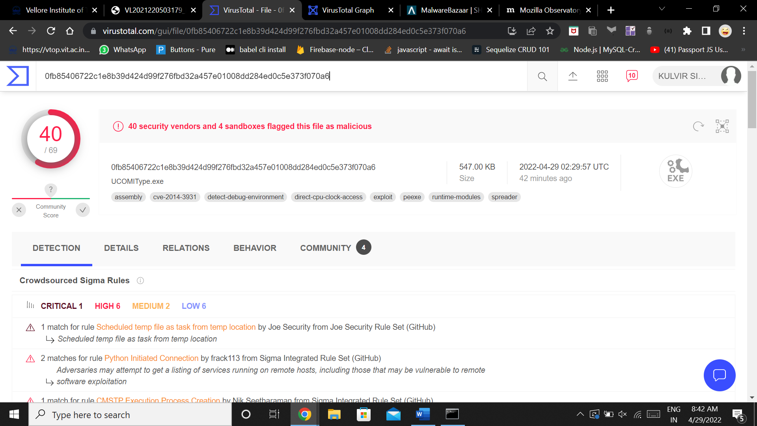

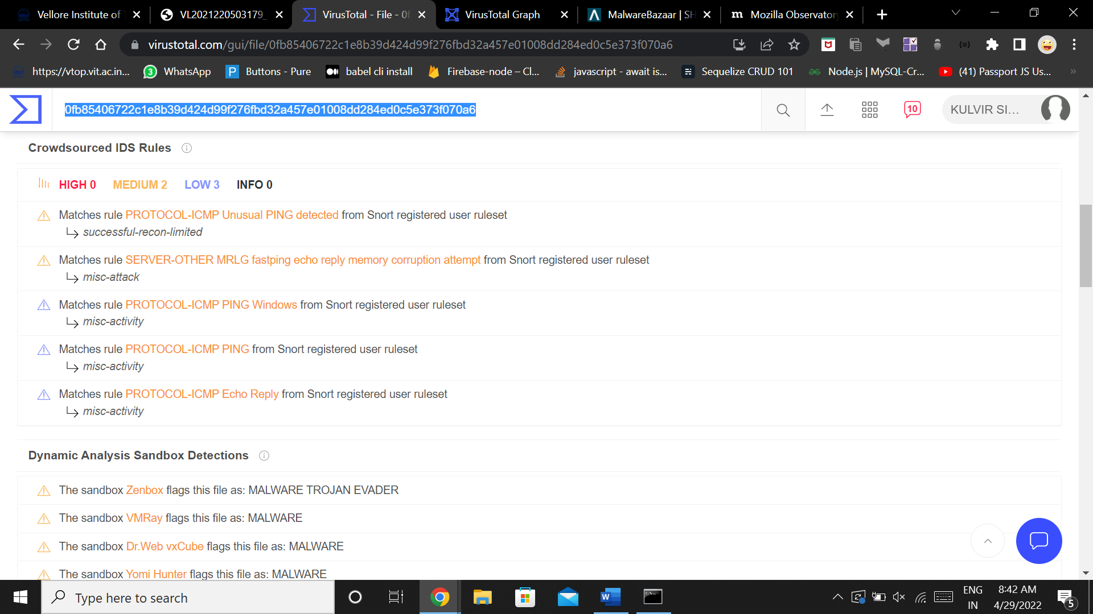

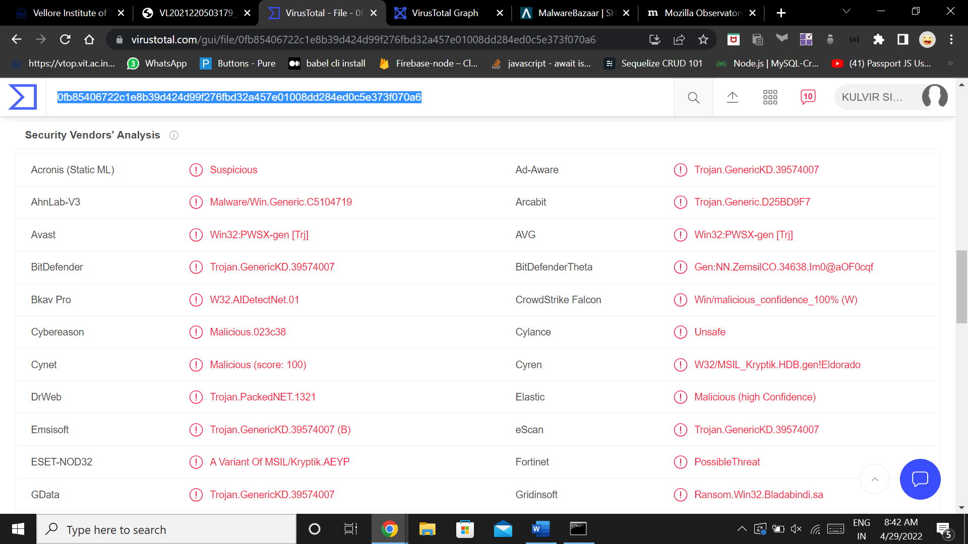

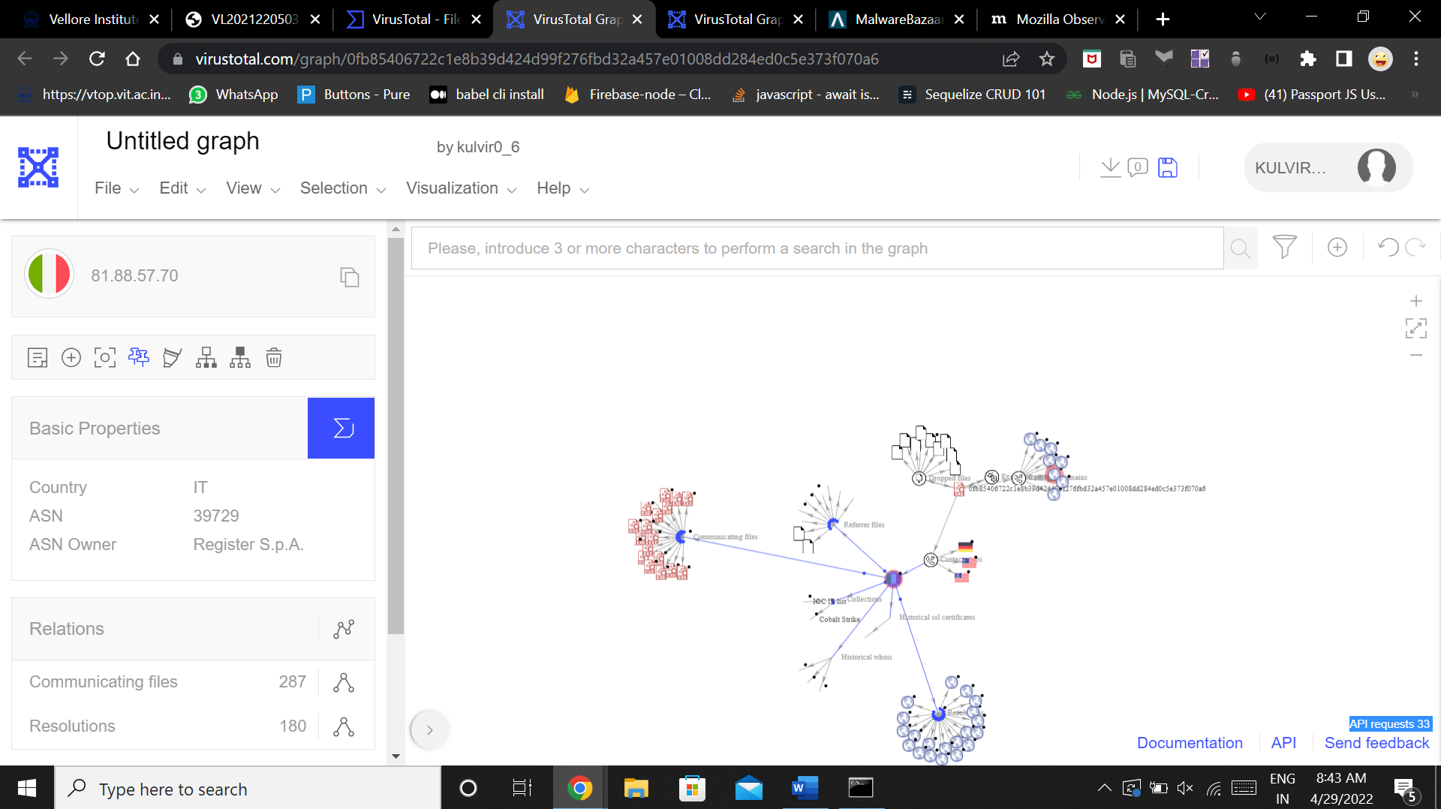

Mozilla Observatory tool :

Using this to perform malware analysis of the malware found in the website :

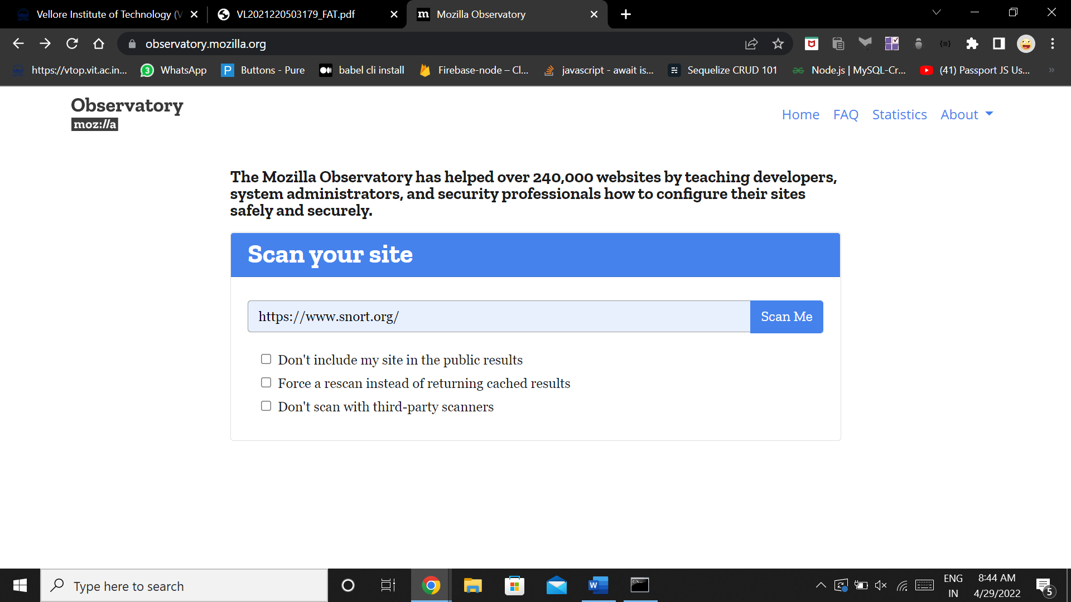

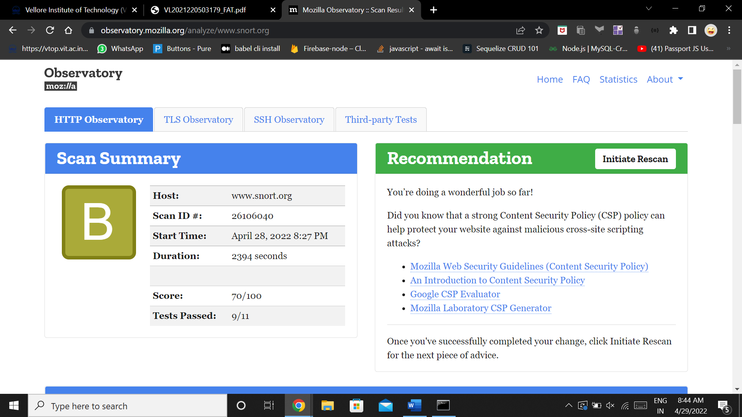

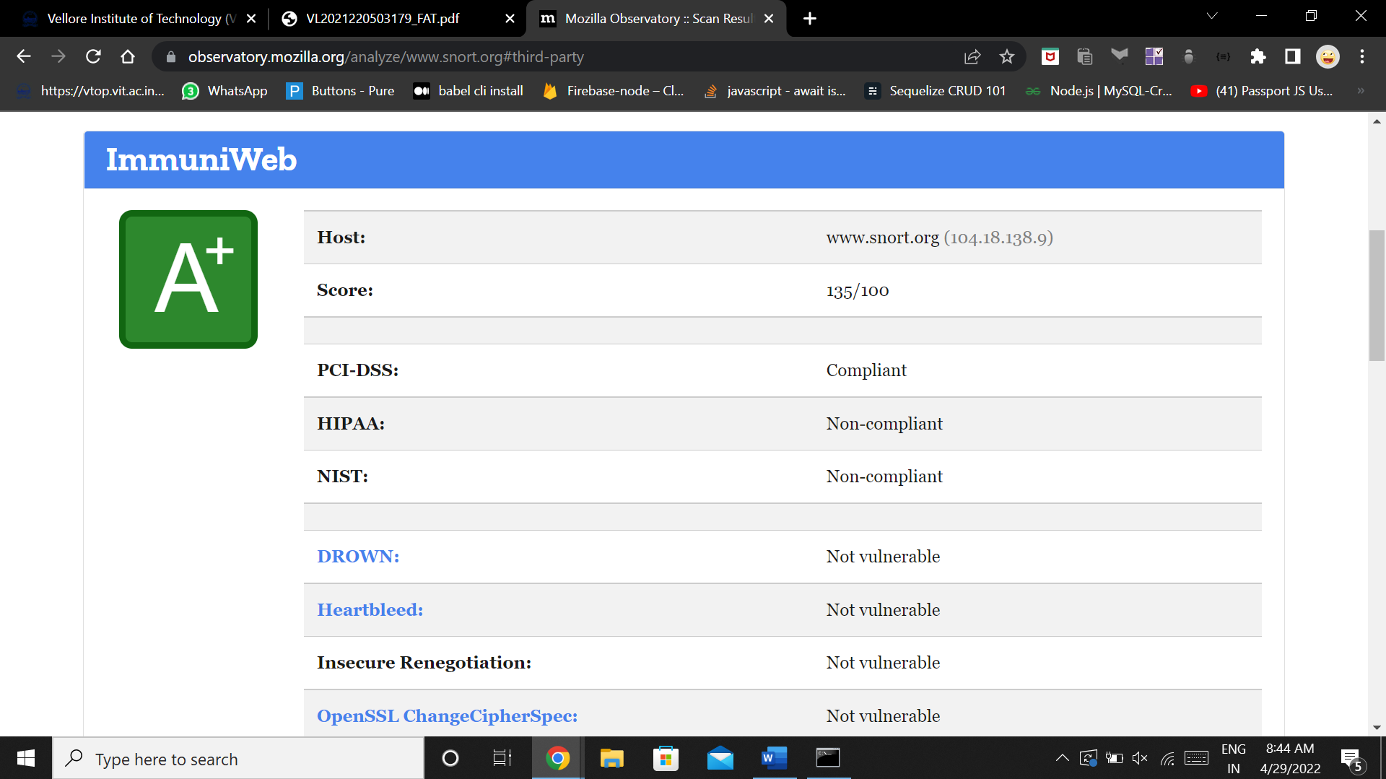

Vulnerable website has malware whose analysis can be seen below :

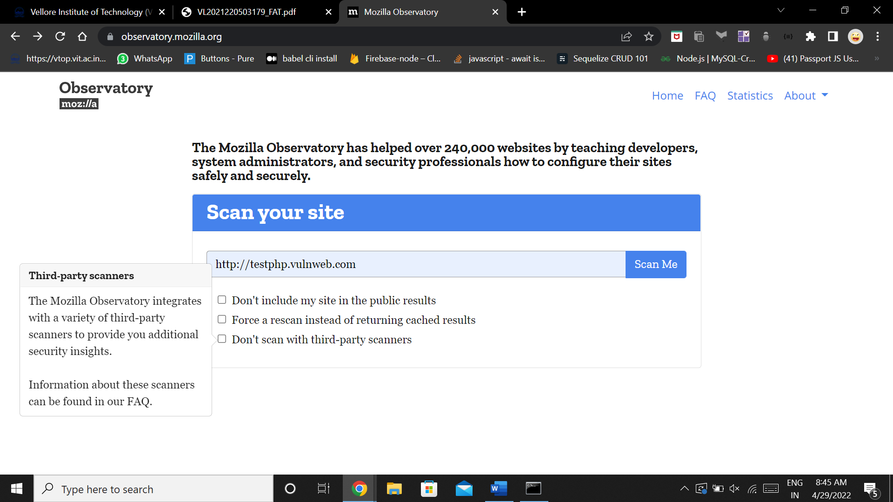

Malware found in the website hence GRADE F is given to the scan

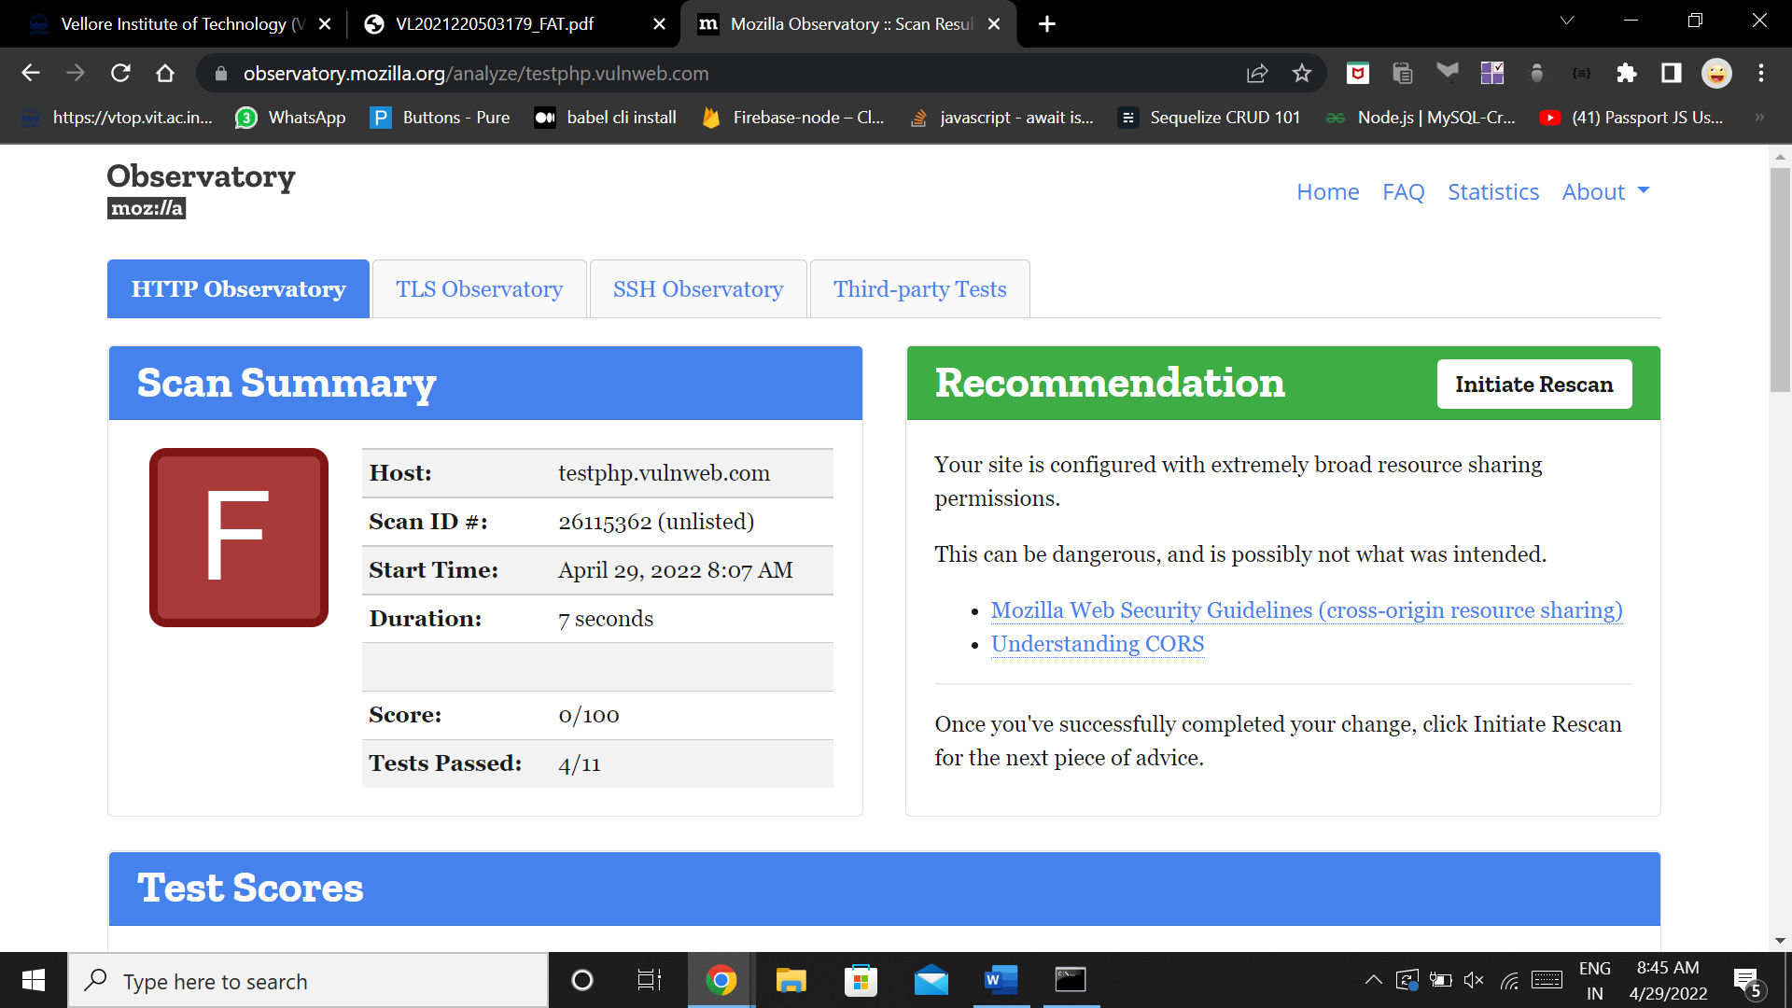

Analysis report of the content security is given below :

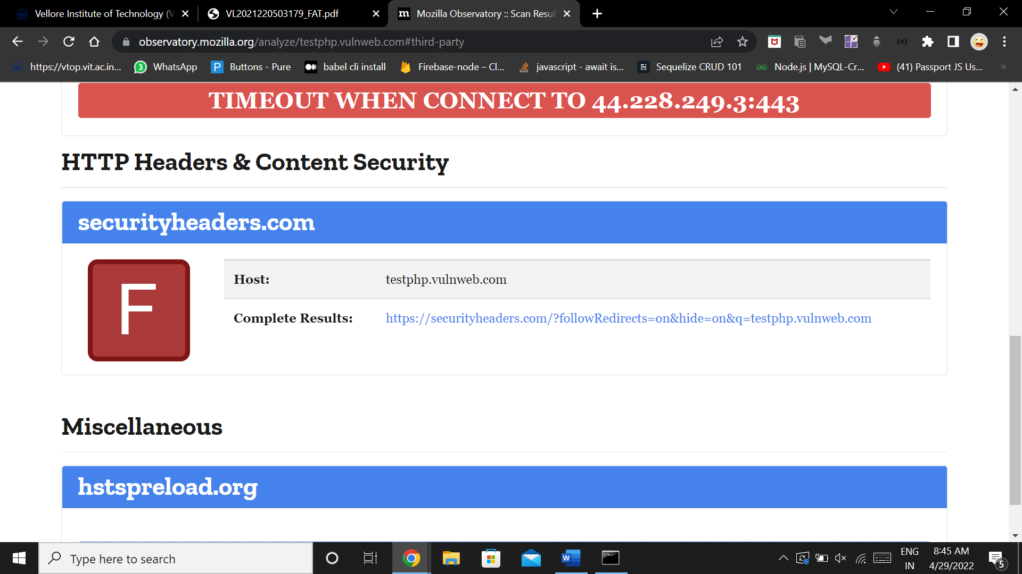

Summary of the malware analysis :

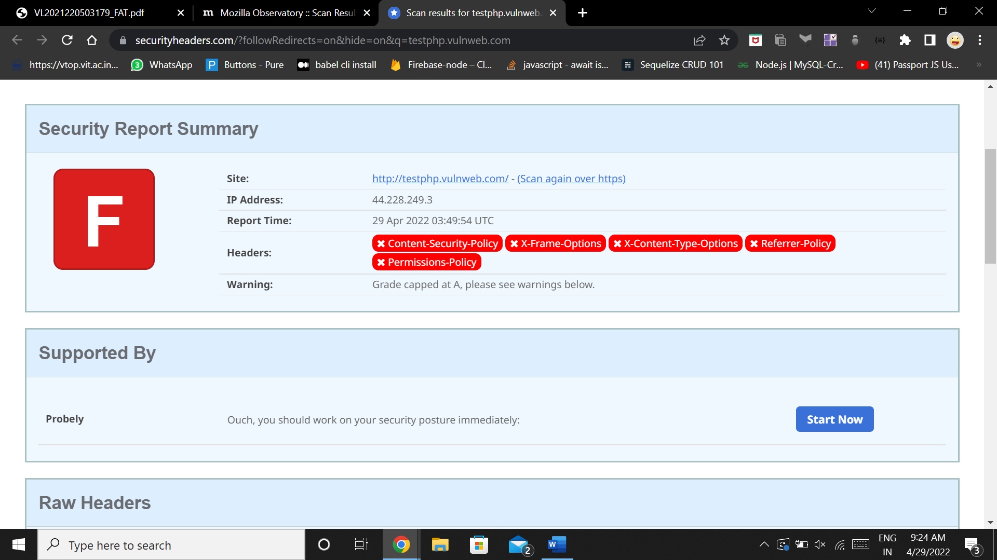

Question 2 )

Login to Nessus

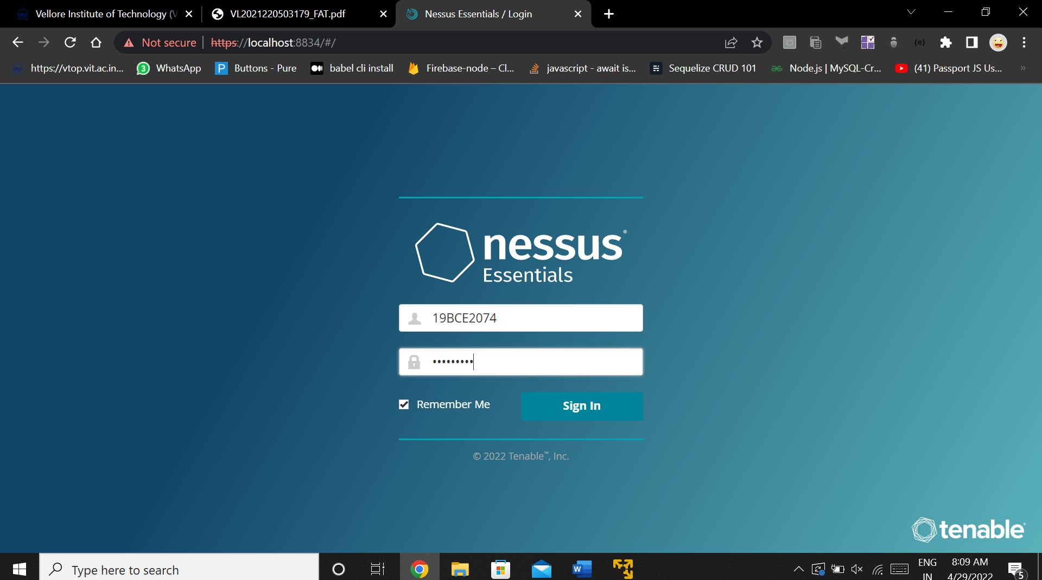

Configure Scan 1 : Basic Network Scan

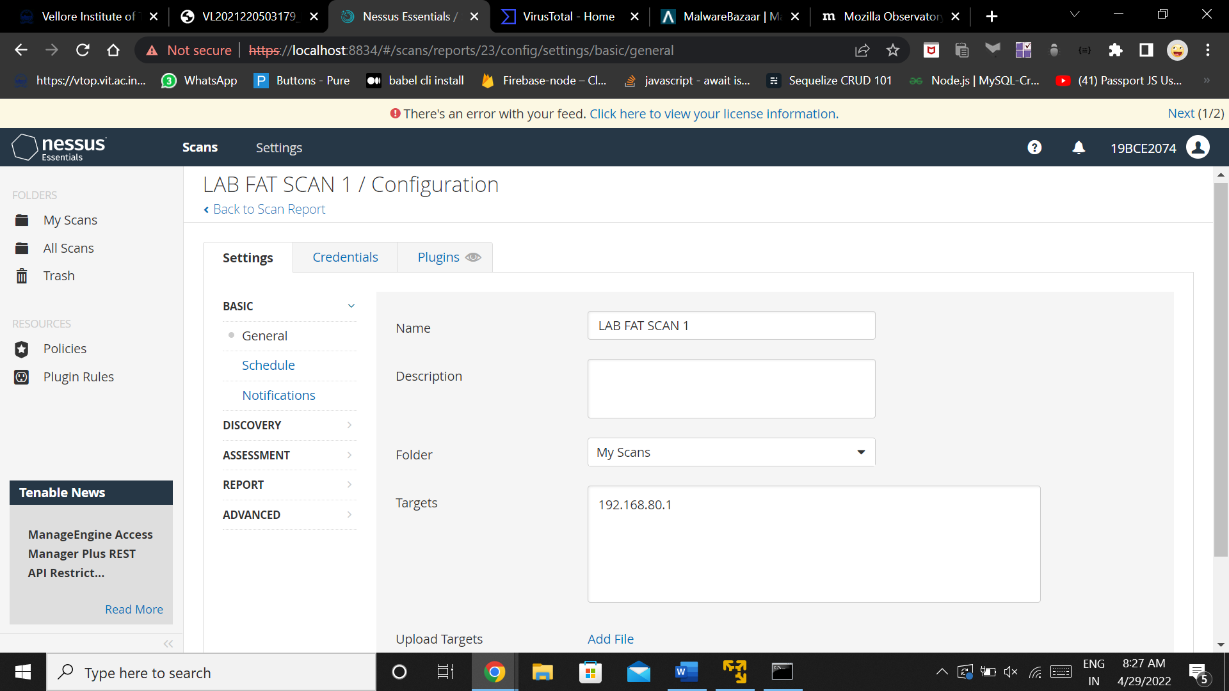

Completion of scan :

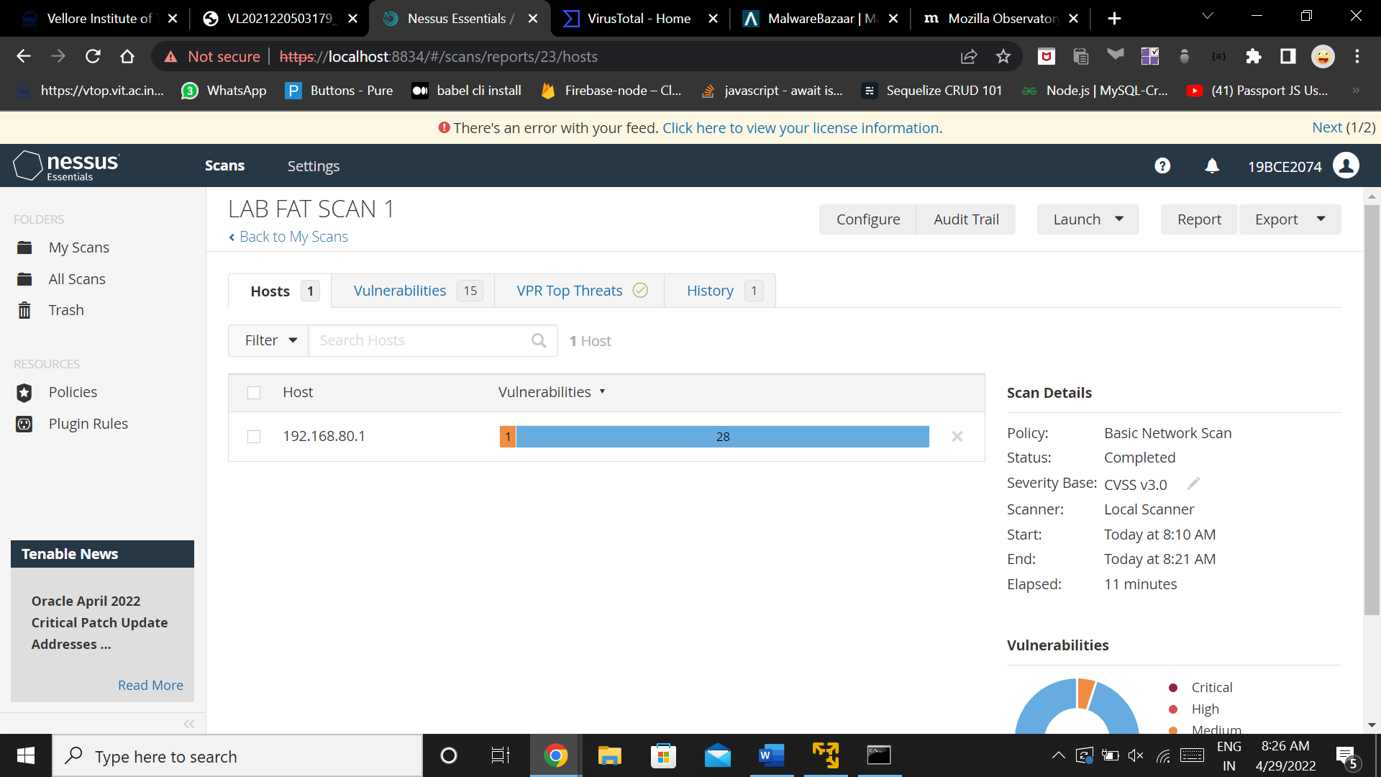

Vulnerabilities detected :

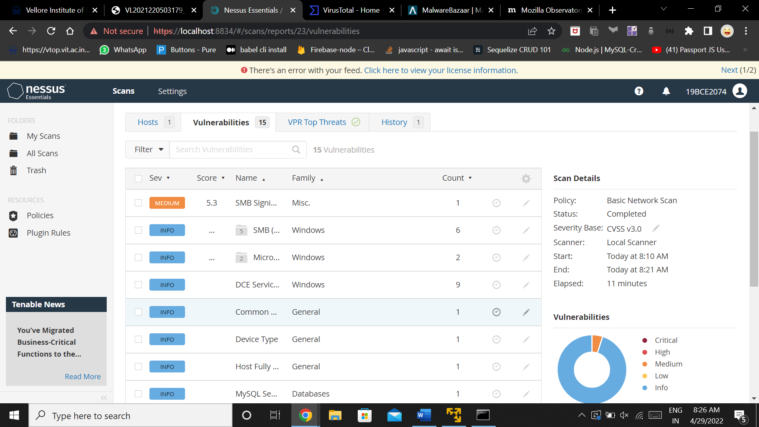

Configure Scan 2 : Web Security Scan

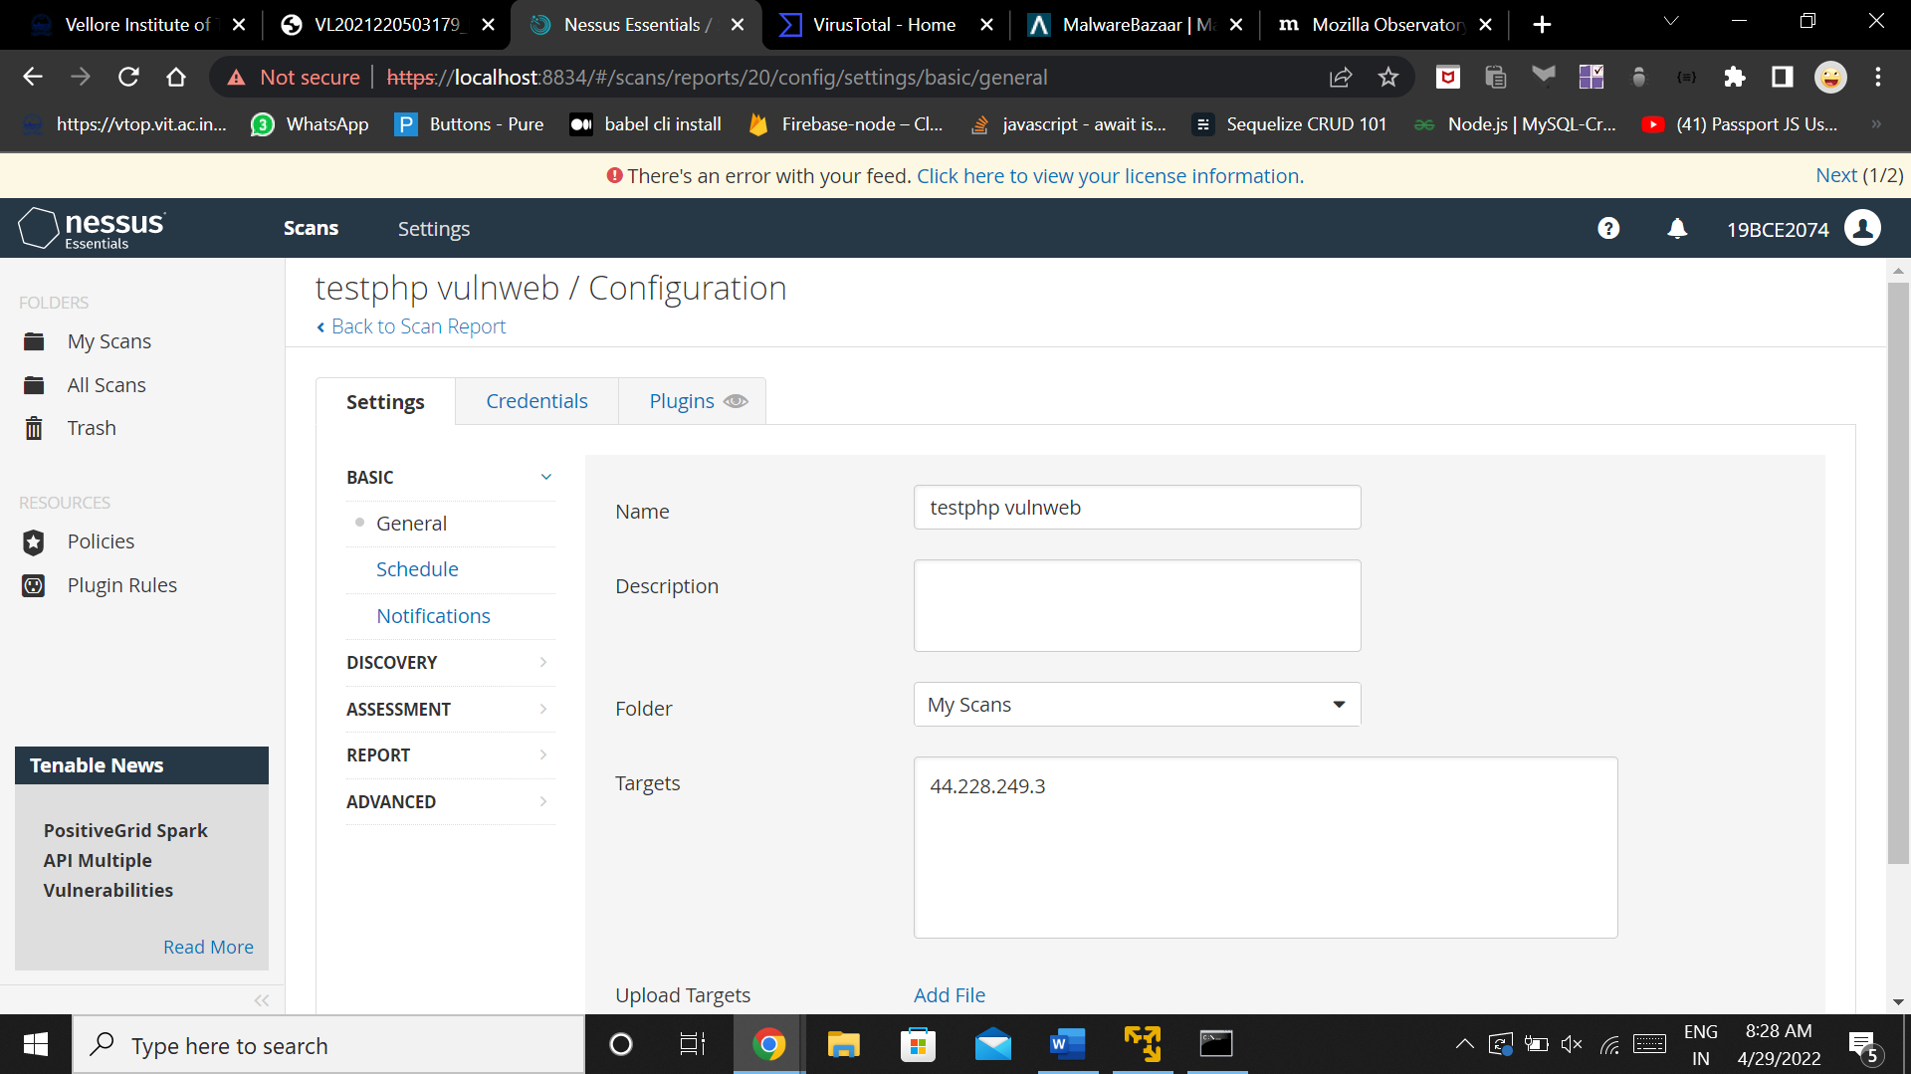

Completion of Scan

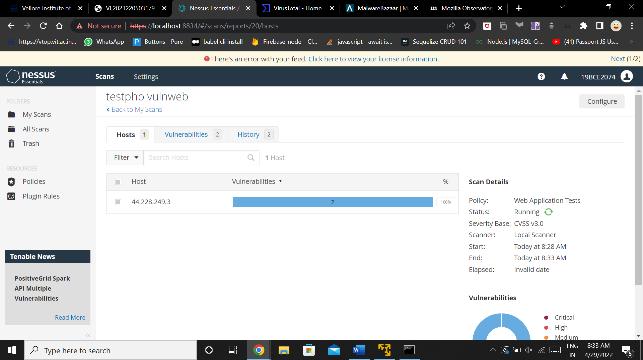

Vulnerabilities detected :

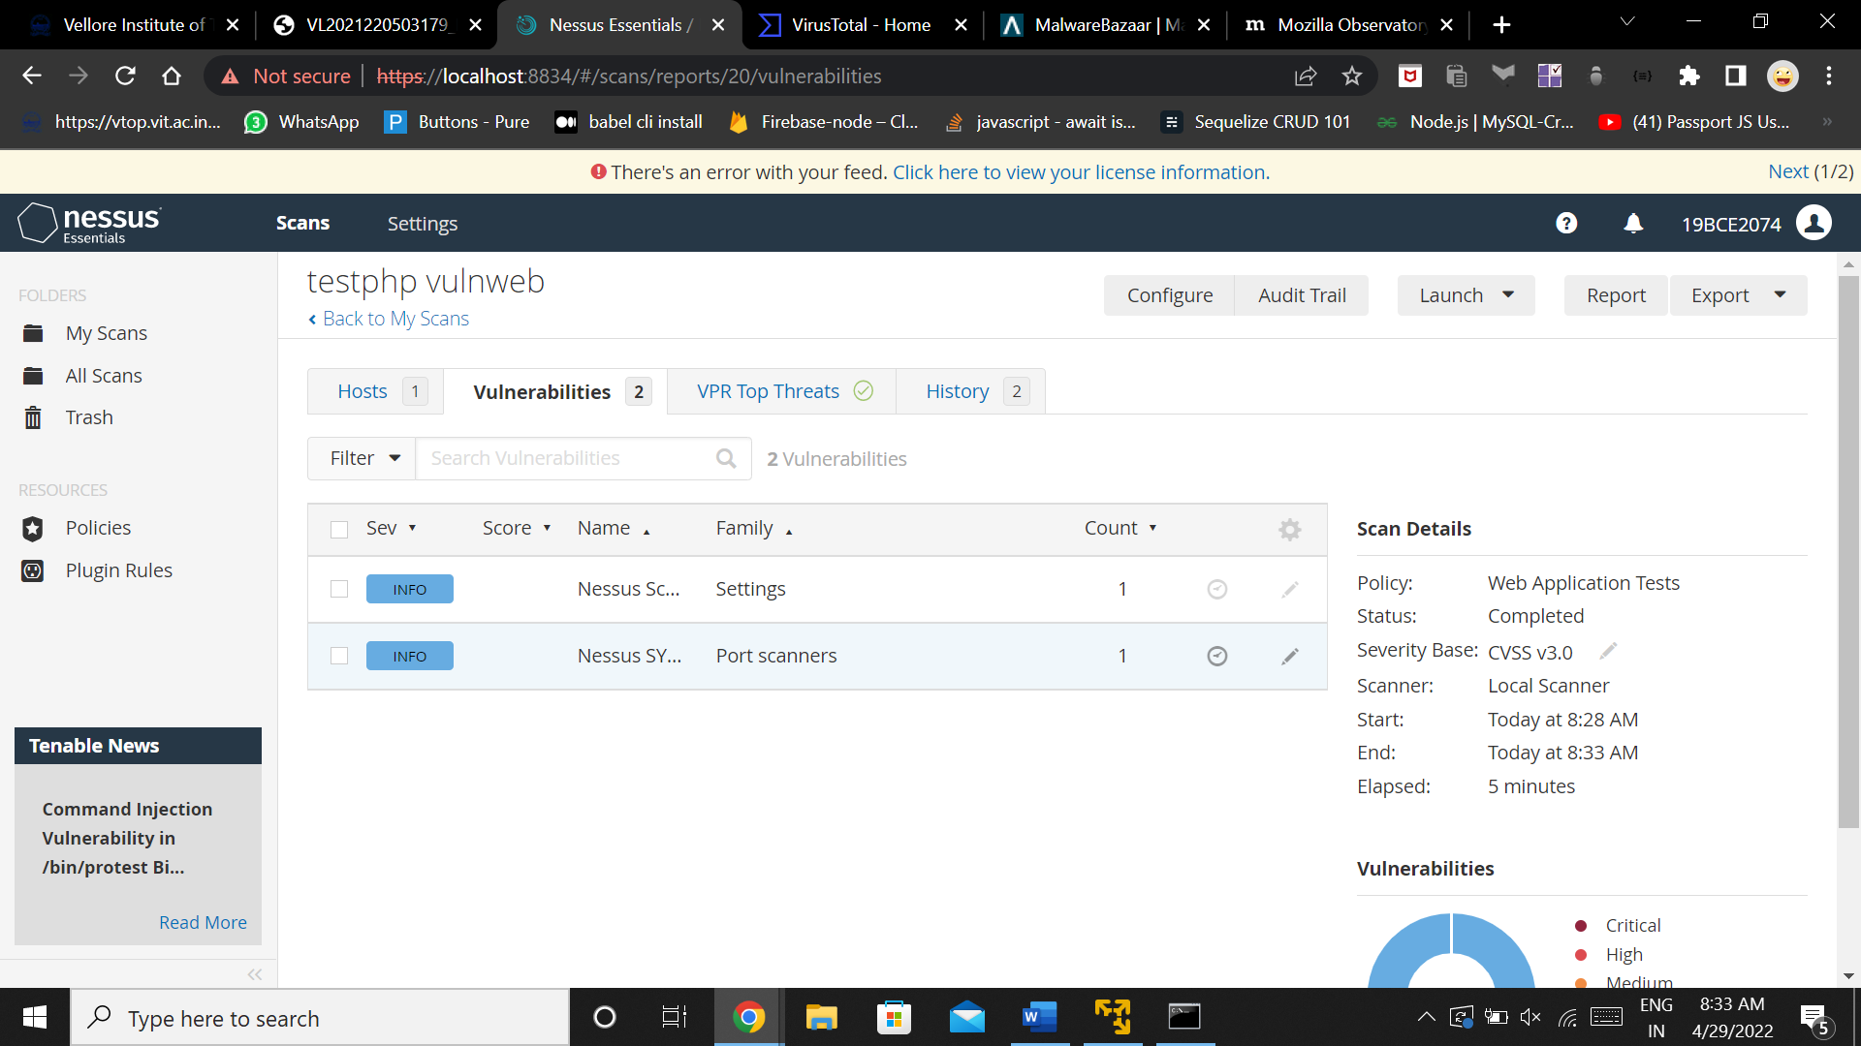

NIKTO :

Nikto -H : help command

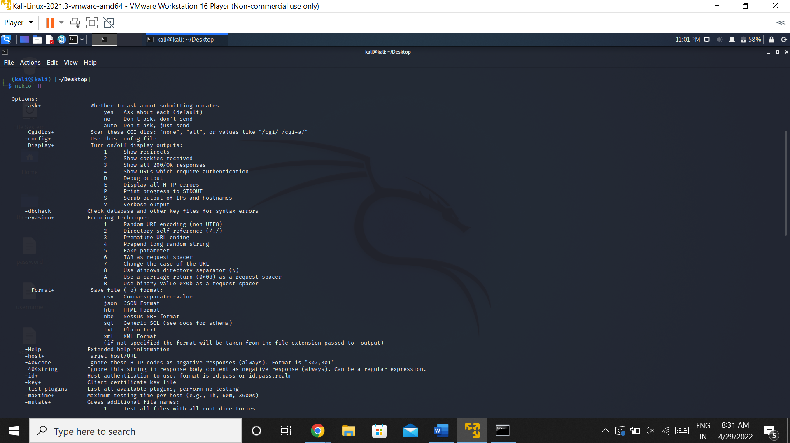

Nikto -h url :

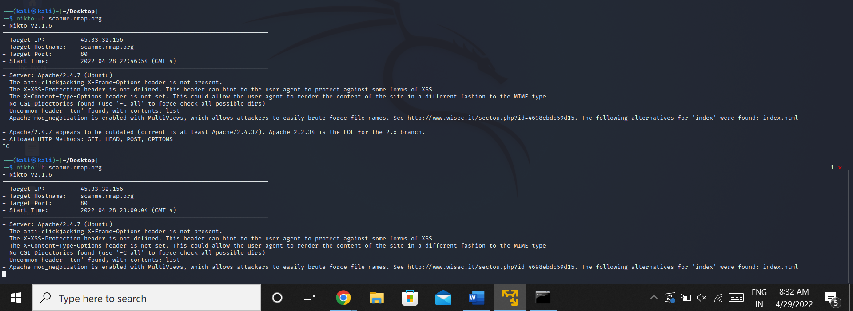

Nikto -h url -ssl

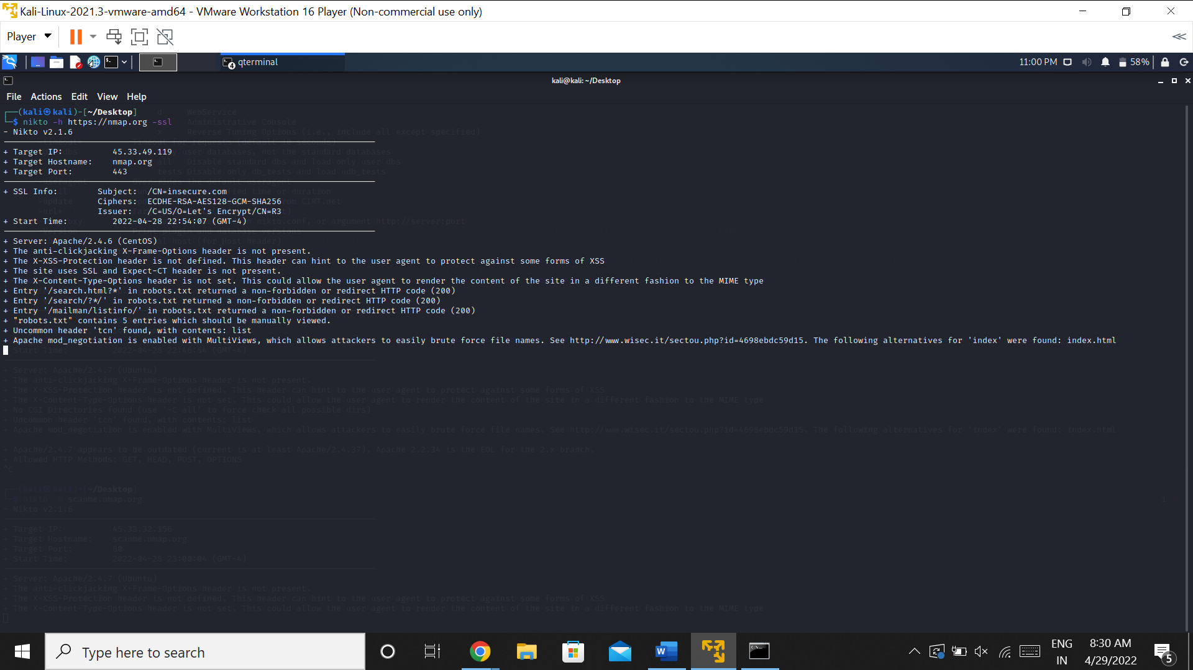

Nikto -h ipaddress

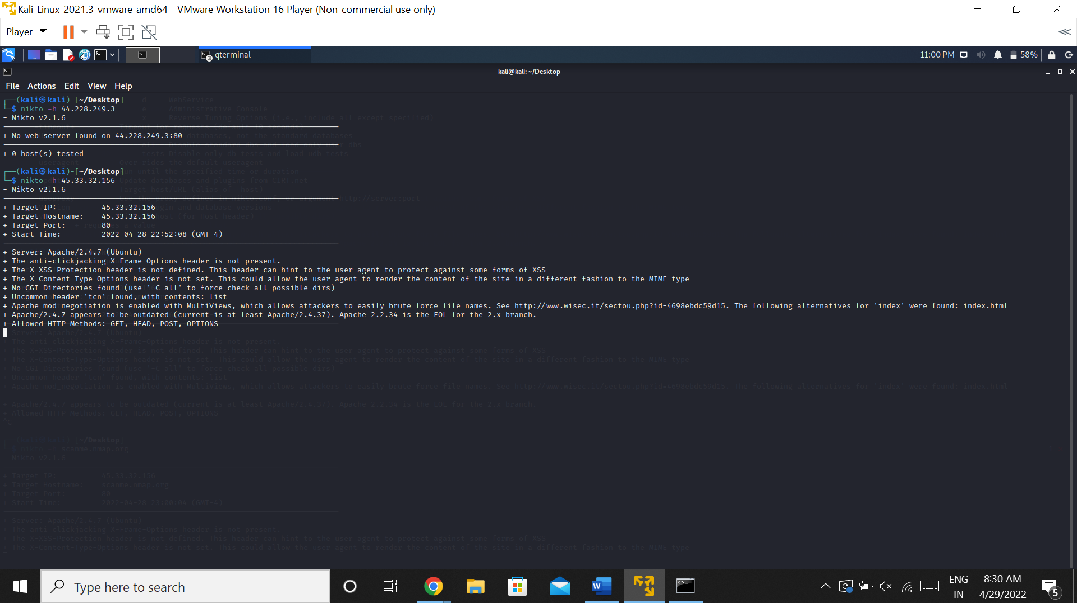

Nikto -h url -o scan.txt

